California State University Fullerton

CPSC 462



Object Oriented Software Design

Use Case Model – Annex 3

for the



<Tuffy Flight>

System

Retrieve Ticket to Board Flight

Fully Dressed Use Case

|  |  |  |
| --- | --- | --- |
| **Nathan Marcos** | **Jared Castaneda** | **Jawad Swed** |
| Design Modeling, Implementation | Project Management, Implementation | Business Modeling, Design Modeling |
| [nathanmarcos@csu.fullerton.edu](mailto:nathanmarcos@csu.fullerton.edu) | [jaredcast@csu.fullerton.edu](mailto:jaredcast@csu.fullerton.edu) | [jawadswed@csu.fullerton.edu](mailto:jawadswed@csu.fullerton.edu) |

Revision History:

| Version | Date | Summary of Changes | Author |
| --- | --- | --- | --- |
| 1.0 | 09/27/2020 | * added the main success scenario * Fixed the main success scenario to differ from the architecturally significant use case and address risk of inability to access purchased tickets * Added stakeholders, primary actors, preconditions, success guarantee, special requirement, technology and data variations list, frequency of occurrence * Added and edit few details to match other documents | Jawad Swed |
| 1.1 | 11/07/2020 | * Added the system sequence diagram for scenario 1 with description * Fixed and added few changes for correctness | Jawad swed |
| 1.2 | 12/06/2020 | * Fixed the goal and the system sequence diagram * Updated roles |  |

Table of Contents

1 Use Case Description 1

1.1 Use Case Title 1

1.2 Scope 1

1.3 Category 1

1.3.1 Risks addressed 1

1.4 Level 1

1.5 Primary Actor(s) 1

1.6 Stakeholders and Interests: 1

1.6.1 <Stakeholder 1> 1

1.6.2 <Stakeholder 2> 1

1.7 Preconditions (Entrance Criteria) 1

1.8 Success Guarantee (Exit State) 1

1.9 Main Success Scenario: 1

1.10 Extensions (Alternate paths) 1

1.11 Special Requirements: 2

1.12 Technology and Data Variations List: 2

1.13 Frequency of Occurrence: 2

1.14 Miscellaneous: 2

2 System Sequence Diagrams 3

2.1 <Scenario 1 Title> 3

2.1.1 Scenario Description 3

2.1.2 System Sequence Diagram 3

2.2 <Scenario 2 Title> 4

2.2.1 Scenario Description 4

2.2.2 System Sequence Diagram 4

# Use Case Description

## Use Case Title

Getting a ticket for flight boarding

## Scope

Tuffy Flights software

## Category

Greatest Risk

### Risks addressed

1. system failure

2.

## Level

User goal

## Primary Actor(s)

* Customer
* Ticket Agent

## Stakeholders and Interests:

### Project Team

Wants to work on the project and keep it running. Wants to draft out new ideas to implement into the booking process.

### Airline Ticket Commissioner

Wants to make money from selling flight tickets.

### Hotel Promoter

Wants Customers to see and click on their ads throughout the booking process. Wants Customers to book a stay at their hotel alongside a flight. Hopes the convenience of booking a hotel is done early and around the same time a flight is booked.

## Preconditions (Entrance Criteria)

User is identified and authenticated with Tuffy Flights software.

Customer has a proper method to pay for the flight. This includes credit card, gift card, or redeemable points

## Success Guarantee (Exit State)

Customer has retrieved the purchased ticket.

## Main Success Scenario:

1. Customer request authentication to the system
2. System responds by granting access to the customer
3. Customer requests to book a specific flight
4. System responds with the specified flight as well as additional flight options
5. Customer requests additional flight options if needed
6. System responds with information regarding the fees and total cost
7. Customer requests to pay for his flight with a valid payment information
8. System responds with a receipt, ticket, and flight information
9. Customer requests the system to retrieve his purchased flight ticket
10. System responds by presenting the user with the flight ticket
11. Customer logs out of the system

## Extensions (Alternate paths)

*a. At any time, if System fails:

1. Customer requests to restart. System responds with previous saved state.

1a. If System is unable respond with previous state.

1. Customer requests to save progress and exit. System responds with save confirmation and exits.

2a. if customer authentication fails

1. the system responds by informing the customer why the authentication failed and requesting the customer to try the authentication process again.

9a. If the customer has no purchased flights

1. System will inform the customer that there is no previously purchased flights.

10a. If the system database fails to retrieve the customer purchased flights information.

1. System retrieves a copy of the customer purchased flights information that is stored on the customer device

1a. if the system fails to retrieve the customer flight information form the customer device

1. the system will ask the user to call support

## Special Requirements:

* Purchased flights are stored on the system database and the customer device
* Multiple language support
* Enough memory space should be available at the customer device to store the ticket on the device when booked

## Technology and Data Variations List:

* The user Flight information are saved and accessible by the customer and the representative admin account.

## Frequency of Occurrence:

100 access per minute

## Miscellaneous:

* What if the representative was not able to access the customer flights information through the admin account?

# System Sequence Diagrams

## <Scenario 1 Title>

Retrieving ticket

### Scenario Description

This scenario is a successful getting a flight ticket. The customer request authentication from the system using his username, password. the system responds by creating a customer session. The customer requests to book a flight using a flight number, number of seats, number of meals and what kind, and number of bags. The system responds with confirmation of the booking and request payment. The customer requests from the system to pay for the ticket with a card number and payment type. The system respond with payment confirmation. The customer request to show the ticket providing the flight number. The system responds with the desired ticket, the customer logs off.

### System Sequence Diagram

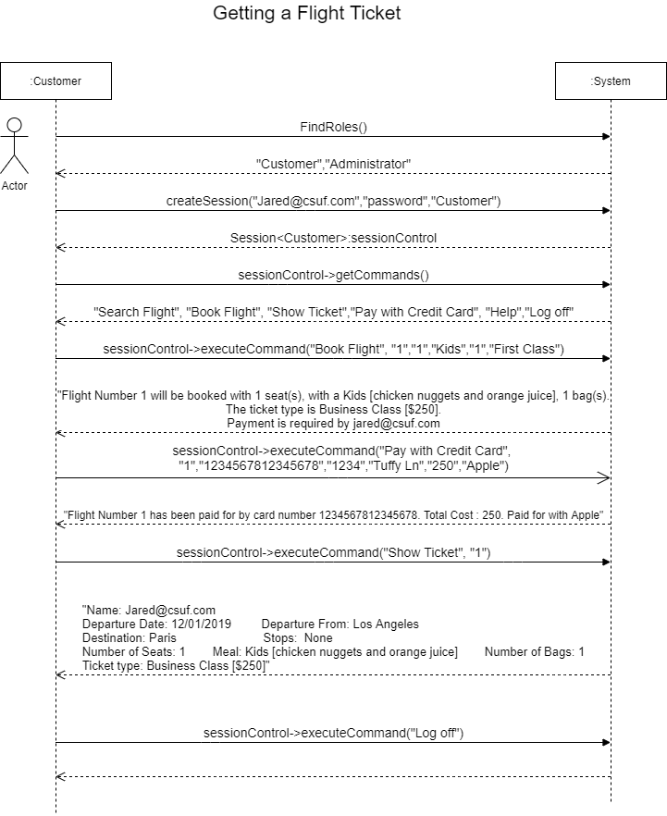

## <Scenario 2 Title>

### Scenario Description

### System Sequence Diagram